OSHA RECORDABLE DECISION TREE

The decision tree for recording work-related injuries and illnesses below shows the steps involved in making this determination.

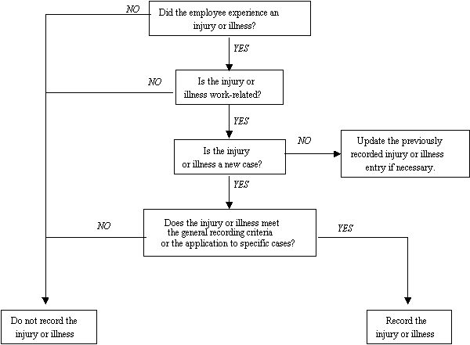
Source: OSHA website
(See 29 CFR 1904.4)

